OVEC CELL Partners
Parts with different roles and functions working together
for the good of the whole!
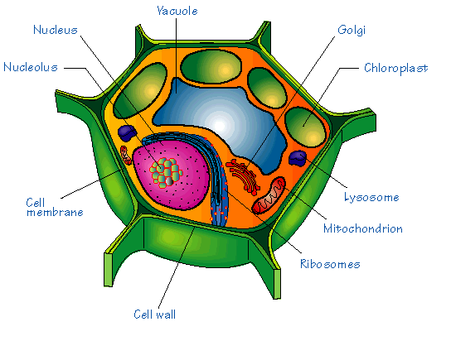
Cell Membrane Group: Your district partners

Nucleus Partner: This is someone teaching the same grade/subject as you.

Name:

Mitochondrion Partners: These members get energized by the power of their cooperative planning. They are 3 other people who teach the same grade/subject in a different district.

Name:
Name:
Name:

Ribosome Partner: You will build a strong relationship across different districts. This partner is someone who teaches a different grade/subject in a different district.

Name:

Vacuole Partners: These partners take in information from other grade bands to use to clarify understanding. Choose two other people to form an E/M/H team.

Name:
Name:

