Guidance around NGSS Curriculum Mapping Decisions

The process of creating a useful curriculum map likely begins with ‘bundling’ the performance expectations (PEs) into instructional units. Different ways to bundle have been suggested in literature related to the NGSS ranging from a focus on one, to all three of the dimensions of the NGSS. The following guidance is based on bundling of PEs which incorporate all three dimensions of the NGSS; Disciplinary Core Ideas, Science and Engineering Practices, and Cross Cutting Concepts. There are a number of factors that can potentially influence how these bundles are configured. Factors to consider in creating bundles might include:

- Similarities in content-Are there certain ideas that logically belong together?

- Instructional efficiency- Do some performance expectations listed in different topics within the science make sense together because of factors other than content (such as requiring similar math skills or using similar lab practices)?

- Collaboration opportunities- Would bundling in a certain way allow for cross-disciplinary planning? For example, an economics unit in social studies could be taught together with a science unit that is intentionally bundled to include the performance expectations addressing cost/benefit analysis and constraints on design solutions to reduce human impacts?

- Access to resources- Do certain bundles of PEs make sense because a useful resource exists to aid in instruction when configured in a particular way? Some examples include local partnerships with industry or professional organizations, access to science/engineering practitioners or access to facilities.

- Incorporation of the Engineering Design standards- Do certain configurations of PEs allow for a logical and relevant opportunity to engage in some or all of the Engineering Design (ETS) PEs for the grade band? The Kentucky Core Academic Standards for Science (KCAS) assign all of the appropriate grade band Engineering Design (ETS) standards to each grade level, so the unit bundles for every grade/year need to incorporate all Engineering Design standards.

When considering these factors, it is likely that any grade level or course can be configured in multiple ways that are equally reasonable and instructionally sound.

The bundling process:

The KCAS incorporates the topic version of the NGSS, so the performance expectations are already sorted into topics. The most simplistic approach to bundling would be to simply adopt the PEs in each topic as individual units, but this approach has only speed as an advantage. There are significant disadvantages of this approach because it considers few of the factors noted above. This approach is also incomplete because it does not incorporate the engineering design standards into the other topics in a thoughtful way.

A more thorough approach is to intentionally sort the performance expectations based upon their individual content. A process to consider is to enlarge and print all of the performance expectations(http://education.ky.gov/curriculum/sci/Documents/Science%20Curriculum%20Mapping%20Cards.zip) for a specific grade/course, then cut them apart into individual slips so they can be physically manipulated. These slips can be configured in multiple ways until agreement is reached on the most useful instructional groupings. It is recommended to print multiple copies of the ETS standards if using this process, because they can be incorporated into multiple bundles. Doing this also helps to discourage creating just a single engineering design unit that doesn’t tightly integrate with other concepts for this course.

Bundling is the first step in both curriculum mapping and also instructional unit design. For more detailed guidance on creating true instructional units from these bundles, download the KDE Guide to Developing Standards-based Units (http://education.ky.gov/curriculum/docs/Documents/How%20to%20Develop%20a%20Standards%20Based%20Unit%20of%20Study.pdf)

Sequencing the bundles:

After agreement is reached on the configuration of the bundles, they can then be arranged into an instructional sequence.

Sequencing considerations:

- Are there particular PEs or dimensions within the PEs that serve as strong “linkages” –or “transitions” between units? Do those links imply an instructional sequence; in other words, must one unit be taught first in order for the link to make sense conceptually or instructionally?

- Does the instructional sequence tell a coherent “story”? Is there a logical progression of the units so that each ‘flows’ into the next in a way that provides students with opportunities to discover connections and the interrelated nature of the various disciplines of science?

- Are there external factors that must be considered in establishing a sequence, such as seasonal availability of resources, sharing of materials, length of time needed for ongoing investigations, etc.?

- Are there instructional connections that can be made across content areas? For example, are there mathematics concepts that must be mastered earlier in the year before a science concept can be taught?

Documenting the process:

In an attempt to validate this curriculum mapping process and uncover any potential difficulties, a team of teachers worked to bundle and map the standards for three courses: 1st grade, 8th grade and a high school earth science course. Two separate models were created for each grade and the thinking that led to each configuration is shared below.

The first attempt, which was done without incorporating the engineering design standards, resulted in the bundling of the standards into the following five groupings, plus a single outlying standard:

Earth History
Fossil Record
Heredity and Evolution
Human Impacts
Weather and Climate
*Energy 08-PS3-1 (see note below)

Next, we considered if there were PEs within these bundles that might serve as useful transitions to instructionally and conceptually link one instructional unit to the next. Performance expectations were chosen that establish a logical link and were specifically sequenced as ‘bridges’ between bundles Italicized statements in the flow chart summarize the thought processes that resulted in the following selection of transitional standards.

After considering transitional performance expectations the sequence of units plus transitions became:

GRADE 8-A

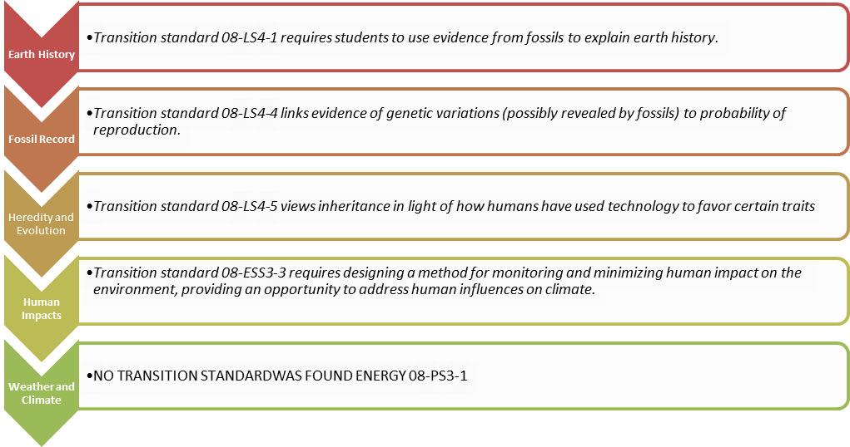

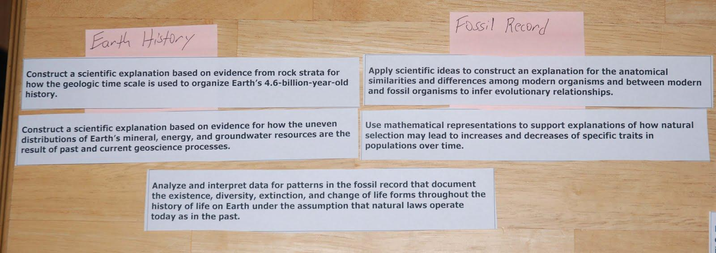
The single outlying standard noted above, performance expectation 08-PS3-1, is the only physical science standard in 8th grade. It was placed in eighth grade primarily because the necessary mathematics (CCSSM 8EE1, 2; 8F3) is also required by the Common Core at this same grade. As noted above, this bundle configuration established no strong link between this standard and the others, nor did we find a strong transitional idea between this standard and the other bundles. For this reason our team decided this would be an excellent opportunity to co-create an integrated experience with the math teacher. Students would be given a chance to apply their understanding of algebra to graphically explain kinetic energy as it relates to mass and speed. This would provide the math teacher much-desired context for authentic application and development of students’ ability to use mathematics and computational thinking to support their scientific learning.
Figure 1 Model represents the identification of transition PE

Bundling and sequencing were guided by the idea of creating a coherent instructional “storyline”. We thought about how instruction would flow in a logical way from one unit to the next and how the year-long instructional sequence would make sense to parents and students. For the sequence above the simplified storyline is below.

The year begins with learning about earth history and uses the ideas of information from the earth to transition into knowing how this information builds understanding of how organisms have changed over time. Natural selection is the transitional idea leading into genetics and heredity. The concept of how humans influence traits leads into a larger understanding of how humans have larger impacts on the entire ecosystem. Using the idea of human impacts leads to the study of global climate and earth systems.

This initial attempt at bundling produced a useful first result. However, we found it to be incomplete because the engineering design standards were not considered. Engineering design standards are an expectation at every grade level so we revisited the bundles while considering the ETS standards. Multiple places were identified within the bundle where the entire design process could be implemented. 08-ESS3-3, Apply scientific principles to design a method for monitoring and minimizing a human impact on the environment*, was the most obvious PE identified to incorporate the ETS standards since it already integrates engineering and requires students to engage in design.

Other bundling options to address the engineering design standards identified were:

- End the year with a “capstone” unit incorporating engineering design. This approach had the significant disadvantage of not providing context for the process and therefore was not further considered.

- Center an engineering design unit based on 08-PS3-1, the lone physical science standard in 8th grade. Choosing this option could potentially reduce the difficulty encountered in the first attempts above by integrating this standard into a comprehensive engineering design experience.

- Bundle 08-PS3-1 with 08-LS1-8 to explore the relationship between mass, kinetic energy and human sensory responses and their influence on automobile stopping distances.

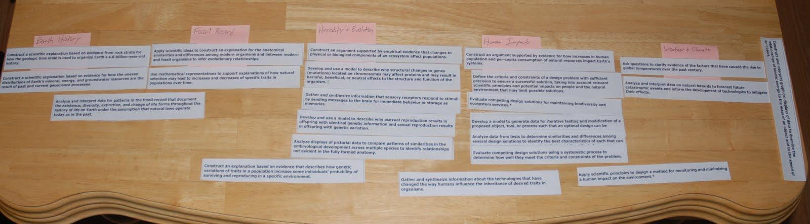
Figure 2 Bundles with transition PEs

Grade 8B

Based on the work done to develop Grade 8- A course, the team decided to develop second course that would illustrate how similar bundles could be arranged into a different, yet logical instructional sequence, the group revisited the bundles to intentionally create a different sequence. This time, unlike in the development of Grade 8- A, instructional transitions were explicitly sought during the first stages of bundling. Decisions regarding sequencing those bundles were made concurrently with the bundling and identification of transitions, making this approach more efficient than the one attempted first.

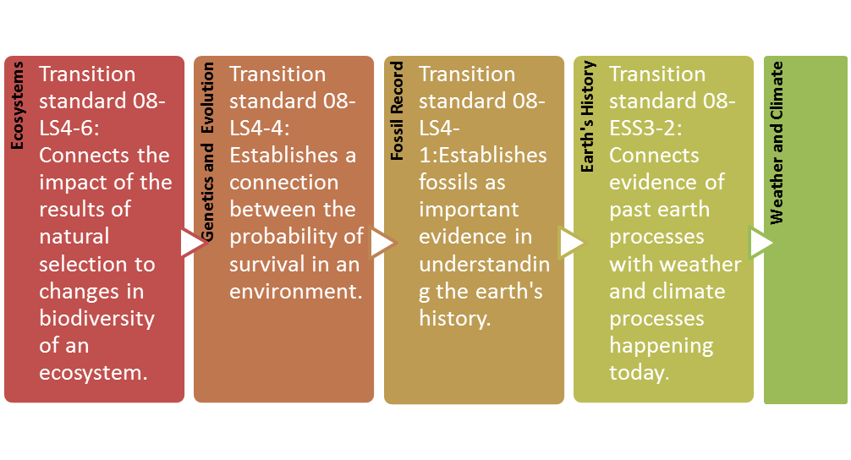
Grade 8B

Bundling and Sequencing:

In the development of this sequence we planned for the engineering design standards to be intentionally introduced in the first unit of the instructional year focusing on 08-ESS3-3. The decision to begin with the ecosystems unit was made in reaction to the availability of access to an outdoor classroom and also the scheduling of an instructional field trip. Although the instructional units are relatively unchanged as compared to the previous configuration, those changes made regarding sequencing and the bundles resulted in a different instructional story as well as a change in some of the linking standards used to connect the concepts.

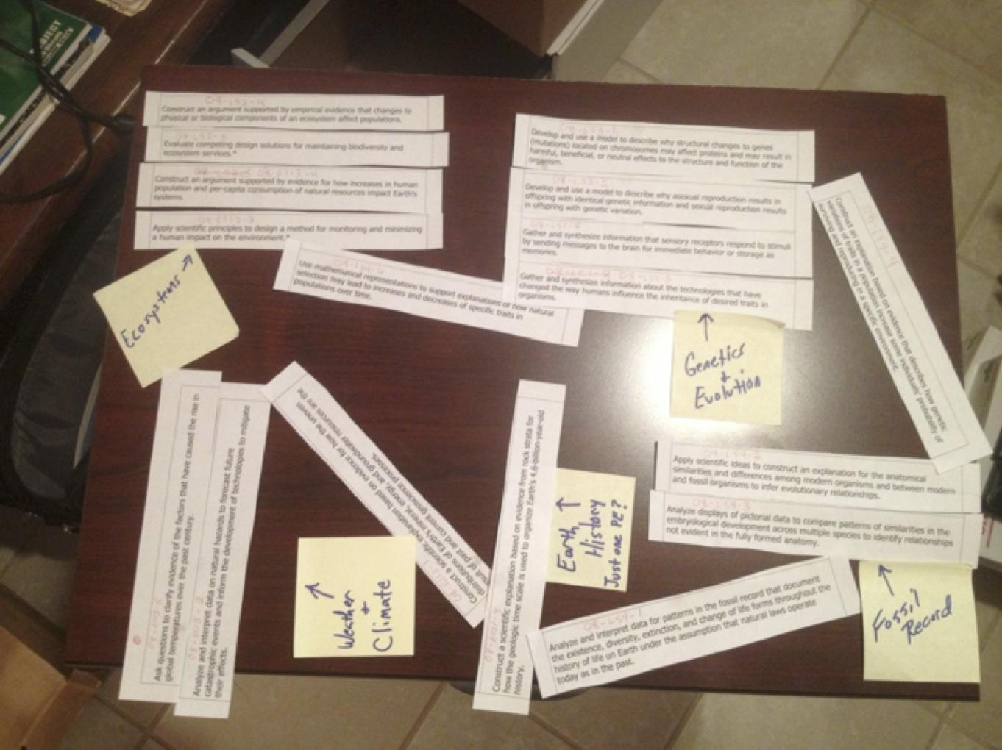
Figure 3 represents a model of our collective thinking for storyline 8B.
Storyline for Grade 8-B

Ecosystems will start this 8th grade storyline with a focus on biodiversity and populations. The practices associated with the ETS standards can be introduced with this unit focusing on human impacts on the environment and natural resources. How changes to an ecosystem over time influence certain traits through natural selection transition to the Genetics and Evolution unit.

This second unit looks at how organisms can change through mutations and new technology can influence desired traits of organisms. Genetic variation is also examined through the different types of reproduction. Establishing a link between the study of past organisms and change over time will connect to the next unit called the Fossil Record.

Students will compare modern organisms with fossil organisms. The importance of fossils as evidence to understanding Earth’s History leads into this next unit.

Data from rock strata is used as evidence to help explain earth’s geologic past. Analyzing how past and current geoscience processes influence the uneven distribution of earth’s resources will connect this earth history unit with Weather and Climate.

This final unit will have students investigate the contributing factors of the rise in global temperature over the past century. Data will be analyzed of past natural hazards to forecast future catastrophic events.

Grade 1- A

When developing the Grade 1 bundle, one group of teachers chose to separate the standards into four instructional units. It was discovered that these units essentially mirrored the topics of the KCAS document, but differed in that the ETS standards were integrated with a PE from light and sound to create a separate unit. The four units in this curriculum map are:

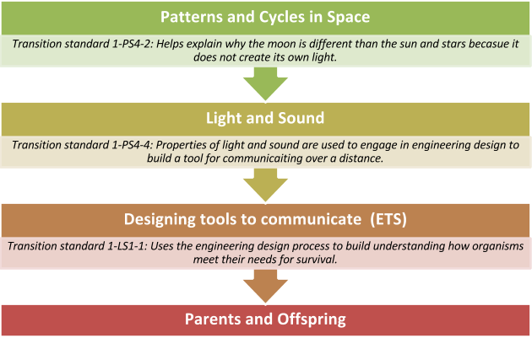

The transitions PEs were chosen after much discussion about the flow of the units when developing a possible storyline for this grade. Our thinking was that 1-PS4-2 connects the learning about illuminated objects in space to understandings about light. The transition 1-PS4-4 connects the engineering unit in which students will design and test solutions to a problem by having them develop devices related to this topic. Finally, 1-LS1-1 allows students to use their engineering skills from the previous unit to design solutions to a problem involving living things.

Given collective thought to another way to approach bundling the topics in first grade resulted in the following:

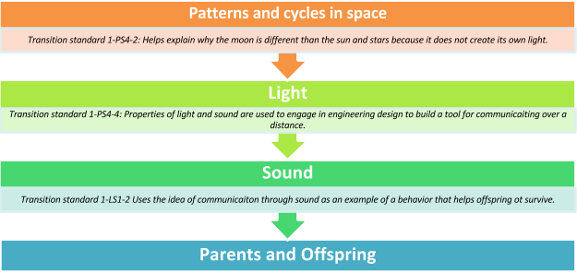
Grade 1-B

(The ETS standards are fully integrated within the units and not as a separate unit unlike the previous example.)

Storyline for Grade 1- B:

The storyline for this approach begins with the patterns and cycles in space because students will need to collect data throughout the year in order to observe the pattern of day light over a period of time. The unit will be ongoing throughout the year. The transition 1-PS4-2 allows students to connect their observations of phenomena they cannot manipulate to those they can as they learn more about light and its interactions with objects. 1-PS4-4 provides a transition to the sound unit allowing students to make connections between a previously designed device that is uses light to communicate to one that involves sound when creating a new design. 1-LS1-2 transitions to the parent and offspring unit by addressing ways that organisms use light and sound to communicate. There is no separate ETS unit in this bundle. Instead, each unit will incorporate all of the ETS standards aligned to the K-2 grade band. Students will be asked to define a problem , determine how objects function to solve problems, and compare solutions to problems, all in the context of the DCIs incorporated in that unit.

High School:

The high school example was created for an earth/space science course based on the Science Domains Model Course Map in NGSS Appendix K (Table 5, page 24) adopted by KY .http://www.nextgenscience.org/sites/ngss/files/Appendix%20K_Revised%208.30.13.pdf

Grade HS-A is a linear model with a culminating unit incorporating the engineering design process. For this course we duplicated the process of sequencing and bundling the PEs together that was used in Grade 1.
The Formation of the Universe
We found no single PE that established a strong transition; the two units can be instructionally linked through the idea that residual energy from the formation of the earth is the driving force for plate tectonics.

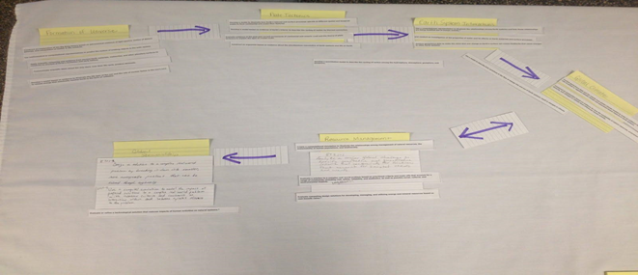
Figure 4 Earth Science Bundle A

Storyline for HS Bundle A:

The Formation of the Universe is a logical conceptual starting point for the instructional year, since the content of this bundle is foundational to all that follows. The bundle of Plate Tectonics was chosen to follow because it was chronologically logical and because the understanding of other concepts is built upon it. There was no PE that stood out as an intentional linking concept, but the concept of residual energy from the formation of the universe as a driving force of tectonics will be used to make the instructional connection.

Earth’s Systems Interactions was sequenced next through the transitional PE of ESS2-6 connecting the cycling of materials in the geosphere to the cycling of carbon through earth’s systems. The idea of systems and energy flow through those systems and the impact on climate of changes of energy levels in ESS2-4 leads to a unit on Global Climate.

The link between natural resource management (usage) and the resultant impact on climate provides a transitional idea for a Unit on Resource Management, followed by a culminating unit/capstone performance task on Global Stewardship. This final unit connects to resource management and incorporates the Engineering Design process by requiring students to engage in designing solutions to authentic world problems.

HS Bundle B

An alternative to the first model for HS Earth Space was created as a result of the teachers’ desire to introduce ETS standards sooner in the school year. An effort was made to find opportunities in each unit to imbed ETS PEs, with the intention being to gradually develop a student’s ability to engage in the entire ETS process. The team decided a theme of ‘Resource Management’ could be interwoven throughout the year with a focus on ETS.

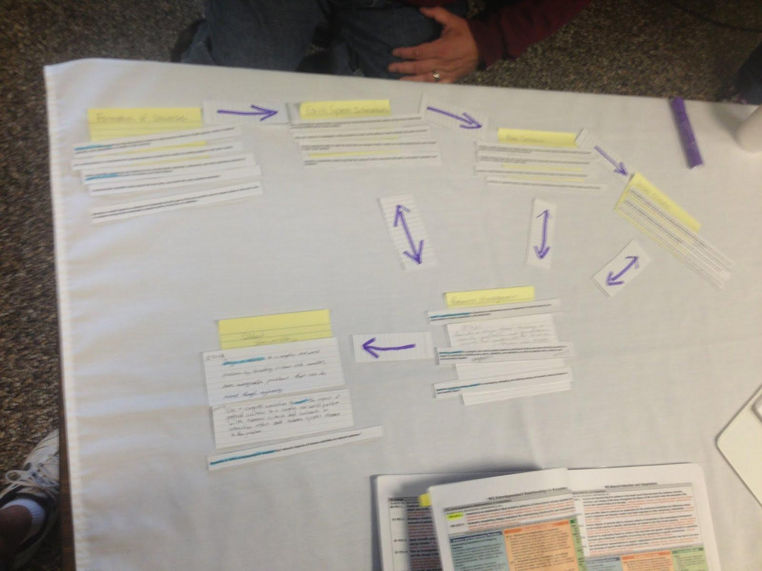
Figure 5 Earth Science Bundle B

Grade HS B

Resource Management

Storyline for HS BUNDLE B:

We begin with a study of ‘The Formation of the Universe’, the foundation of the course. Building on an understanding of the energy of the Earth and how that energy drives Earth systems (ESS1-1) , students will then transition to the study of ‘Earth System Interactions’.
At this point, students will have their first opportunity to apply Earth System learning and ETS through the lens of ‘Resource Management’, a recurring theme to be woven throughout the year.

After the study of different Earth systems, ESS-2-6 offers a bridge to the study of ‘Plate Tectonics’ as one part of the geosphere. Once again, students will engage in ETS using their understanding of ‘Plate Tectonics’ and Earth resources…via ‘Resource Management’.

After ‘Plate Tectonics’, the related natural resources provide a bridge (ESS 3-1) to climate change and therefore a study of the ‘Global Climate’ including causes of climate change. As humans impact climate change, students will continue to develop their ETS skills to engage in ‘Resource Management’.

Finally, students will design, simulate and evaluate solutions to complex real-world problems in an effort to practice ‘Global Stewardship.’ This capstone unit will require students to utilize their understanding of the ideas presented during this course in order to offer potential solutions to the World’s problems.

Next Steps:

Items to consider after engaging in the bundling process for curriculum mapping:

- Look at the identifying codes to see how your thinking followed the topics (or didn’t).

- Look at how well the practices and cross cutting concepts are addressed and determining if any of them need more attention (In example below, one might decide to add activities which incorporate more work with practices 1, 3, and 8 and CCC 1 and 6.)

- Decide if history and nature of science are addressed in appropriate ways throughout grade level(s).

- Compare with different grade levels to determine if the school has a coherent story of science from K-12.

Notes:
This document occasionally interchanges the terms bundle and unit. There is a distinction between the two terms, but sometimes that distinction is more meaningful than at other times. A bundle is a grouping of PEs, while a unit is typically a more complex instructional plan built on the bundles. This document interchanges the terms because bundling of the PEs is the first step in the decision making and planning process that eventually results in the creation of complete instructional units.

This guidance is about sequencing and bundling the standards at each grade level. No recommendations are given that relate to the time parameters needed to implement each unit. Being that these units have not been implemented it is difficult to assign a specific time frame to them. This guidance is the initial step towards creating a useful curriculum map that guides teachers in their planning. It is by no means a static document rather this guidance may be edited as we, all involved in the implementation of the KCAS science standards, gain greater understanding.

