Science and Engineering Practices Activity
Below is a Physical Science (Chemistry) DCI progression from the NGSS Appendix E
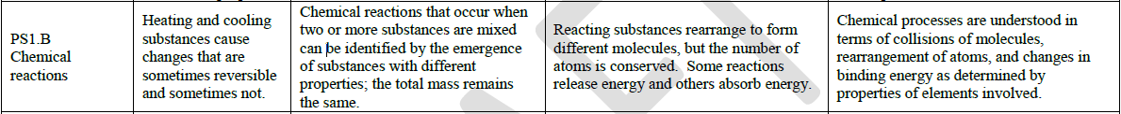
List any current lessons or activities that you have used as part of your instructional unit that aligns to the disciplinary core idea above. | Asking ?/defining problems | Developing and using models | Planning and carrying out investigation | Analyzing and interpreting Data | Using Math/computational thinking | Constructing explanation and design solutions | Engaging in argumentation from Evidence | Obtaining, Evaluating, and comm. Info

B. Mark all of the science and engineering practices that you feel are incorporated in your “old” lessons/activities.
C. Using the Science and Engineering Practice in matrix found in Appendix F, check for the developmental appropriateness of those activities you marked.
D. Reflect on information you have recorded. Do your current activities/lessons provide adequate opportunities to support student learning of the NGSS?

E. * Review the Performance Expectations that incorporate the given life science disciplinary core ideas. Do your current instructional activities/lessons support the depth of learning that is necessary for mastery of the specific PEs?

F. Brainstorm with your table team ways that you can change your current methods of instruction to include more opportunities for students to engage
in the practices.

