Formative Assessment Task 2
6th grade Properties of Matter – at end of 2-week unit

UNIT FOCUS: Properties of Matter – particle level perspective of states of matter and changes when heat is added or removed, but NOT yet about transitioning between states

Performance Expectation target
06-PS1-4. Develop a model that predicts and describes changes in particle motion, temperature, and state of a pure substance when thermal energy is added or removed. [Clarification Statement: Emphasis is on qualitative molecular-level models of solids, liquids, and gases to show that adding or removing thermal energy increases or decreases kinetic energy of the particles until a change of state occurs. Examples of models could include drawings and diagrams. Examples of particles could include molecules or inert atoms. Examples of pure substances could include water, carbon dioxide, and helium.]
Lesson context for 2 weeks of lessons prior to unit formative assessment task
Students for several previous lessons (approximately 2 weeks) have been exploring particle-level behavior of gas and liquid when heat is added. For gas: An example of an experience = balloon on small bottle, put in hot water (expands) and ice water (contracts) and relating this to kinetic energy and spacing of particles. Included discussion of pressure on balloon surface from moving particles (kinetic energy – KE). For liquid: An example of an experience - colored rubbing alcohol put in a thin glass tube with reservoir, then inserted in hot water (colored liquid rises in tube) and ice water (colored liquid goes down) – essentially a thermometer. Asked to consider particle-level behavior (moving faster/slower, more or less space between particles) and extend to idea of phase change from liquid to gas if enough heat added.
Final Lesson context: the final 2 instructional days prior to the unit formative assessment task
Up to the final 2 instructional days, students had not yet explicitly thought about the practice of modeling, nor yet have investigated solids (expansion/contraction) when heat energy is added or subtracted.

Structure of final 2 lessons:
- Overview of practice of modeling
- Students introduced to “people-as-particles” model, and asked to write ideas for how they would model gas, liquid, solid (what they would do, and why)
- Half of class enacts gas model after sharing ideas with classmates, other half is the “lid” of the container and observe.
- Discussion from observers what they saw, how that represents gas particles. Additional comments from enacting half what they intended to do/show.
- Switch roles. Added heat energy to model. Repeat cycle of: (a) planning; (b) enacting; (c) discussing.
- Connect to real-world phenomena (e.g. balloon on container that they did earlier)
- Repeat with liquid (planning, enacting, discussing, adding heat, phenomena)
- Repeat with solid, but begin with demonstration of phenomenon (ball & ring, with heated ball unable to pass through ring). Students asked to model that scenario. Ended with U-shaped ‘ring’ and circle ‘ball’ with students elbow-locked to represent solid particles. The circle just fit into the U when shuffling, but when heated (expanded circle) it didn’t fit.
- Brainstorm and summarize list of strengths and limitations of this modeling approach.
- Applications: bimetallic strip (showed clothes iron deconstructed with bimetallic strip as temperature regulator; thermostat).
Bridges, like the ones in the pictures below, have expansion joints built into them. These are sections of the bridge that are composed of either a hard rubber substance (picture A) or sometimes interlocking teeth (see picture B)
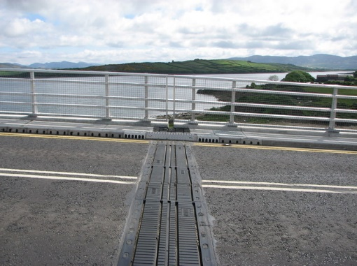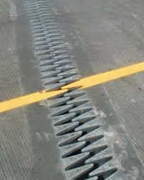
Picture A. Bridge with rubber expansion joint Picture B. interlocking teeth expansion joint

- Draw 2 particle-level models (a cold winter day & a hot summer day) using just 10 particles of concrete on each side of the expansion joint (see below) to describe why expansion joints are necessary.
Cold winter day

Rubber expansion joint

Side view of concrete roadway

Draw 10 particles on each side here

---------------------------------------------------------------------------------------------------------------------
Hot summer day (your drawing here)

Based on your model, why are bridge expansion joints necessary?

How are concrete particles same or different on hot summer day compared to cold winter day?
- Number of particles
- Motion of particles
- Size of particles
- Spacing of particles

- Remember that scientific models are intended to help you think about and understand the science. For any particular model, there are typically strengths for the purpose of understanding, and there are limitations to any model as well. There are also different ways you can create scientific models, and often these different ways have particular strengths or limitations as well.

For this task, you will compare two ways of modeling a gas when heat is added. One model will be using a drawing (below), and the other will be using people-as-particles as you did in class.

MODEL ONE - DRAWING

- For the balloon below, draw a particle-level model of the gas inside (air) at a cold temperature and at a warm temperature.

Balloon at cold temperature  (draw air particles) | Balloon at warm temperature  (draw your balloon and particle model here)

- Compare this drawing model with the “people-as-particles” model done in class by creating a Strengths/Limitations T-chart for each one below. You may have some of the same strengths or limitations for both models, and you may have some different strengths or limitations as well. Include at least 2 strengths and 2 limitations for each model.
People-as-particles model
Limitations
Strengths
Drawing model
Strengths
Limitations

